TMT/Aryan/S0673/2026 17-02- 2026

To,
Aryan kamboj
Mobile: +918182877000
Country: India

Dear sir,

Sub :- Supply of Conventional PRESS BRAKE MACHINE.

Thank you very much for your enquiry regarding your requirement of hydraulic press brake. We are glad to inform you that we would be in a position to supply you the required equipment. Given below are the required specifications and description of the machine and our terms and conditions.

PRESS BRAKE :

1) Size : 2400X 3 M.M.

S No | Description of the unit | Offer
1. | Conventional Press Brake with bending capacity 2.4 Meters and 3 mm MS Sheet | Rs 2,00,000/-  (Two LAKHS ONLY)

GENERAL TERMS & CONDITIONS:

- Price quoted per unit ex-work. Hyderabad.
- Following charges are additional to your account.
  - Freight Charge : As actual to be borne by you.
  - Sales Tax : 18% GST
  - Packing charge : As actual to be borne by you.
  - Insurance : As actual to be borne by you.
- Payment : 50% advance along with order balance before delivery but after inspection at our works.
- Delivery : within 2 months
- Validity : One month from the date of submission.
- Inspection : Inspection at our works prior to dispatch.
- Warranty : The machine is warranted for a period of 12 months from the date of dispatch against any manufacturing defects/ faulty material or bad workmanship of any part or component but not against any kind of abnormal or improper use of machine. Defective part or component will be replaced or repaired free of cost. Electrical components are outside the scope of this warranty.
- Commissioning : Erection & commissioning done by you, but required technical support & guidance provide by us at additional cost.

NOTE:
- Oil is not in scope of our supply.
- Raw material for trial is to be arranged by you at your cost.

We are sure you will find our offer in line with your requirements. Should you require any further clarification please contact 9246221106
Thanking you and assuring you of our best services.
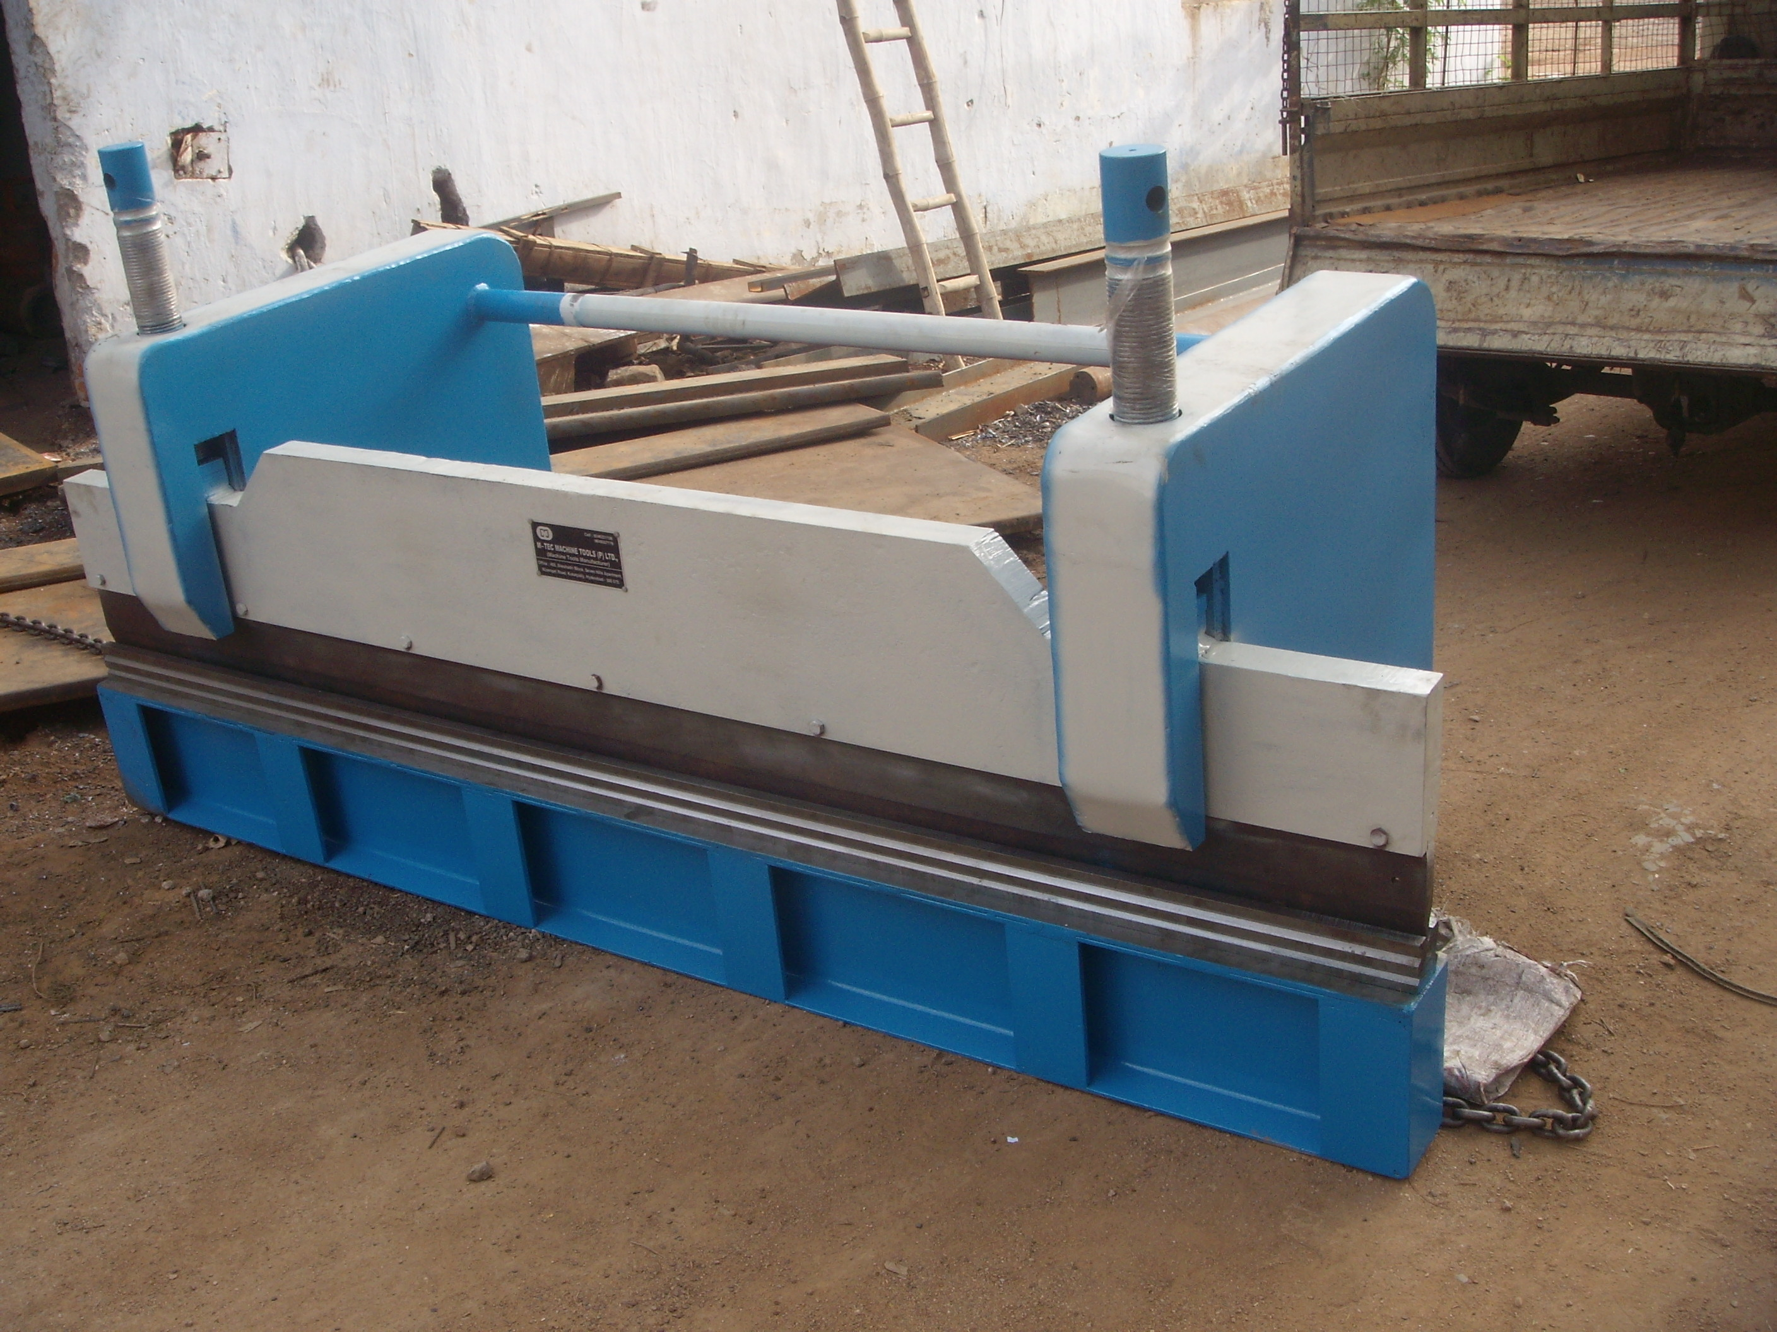

For TECHNO MACHINE TOOLS

( T. SIVARAMA KRISHNA.)

